Assignment no 7
1) Write a query that counts all orders for October 3.
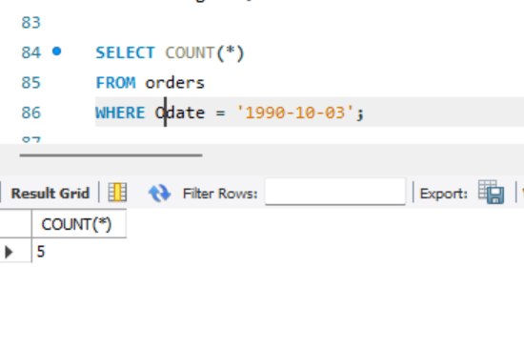
2) Write a query that counts the number of different non-NULL city values in the
Customers table.
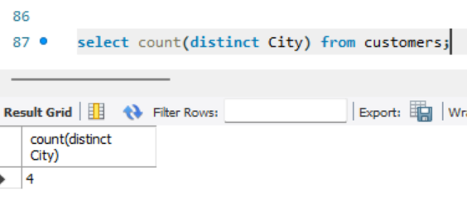
3) Write a query that selects each customer’s smallest order. 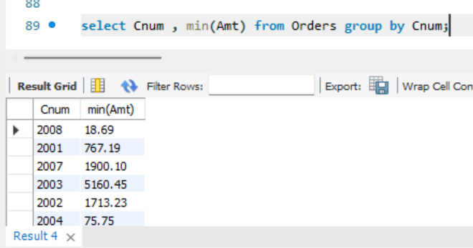
4) Write a query that selects the first customer, in alphabetical order, whose name
begins with G.
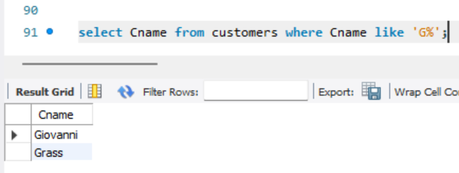
5) Write a query that selects the highest rating in each city.
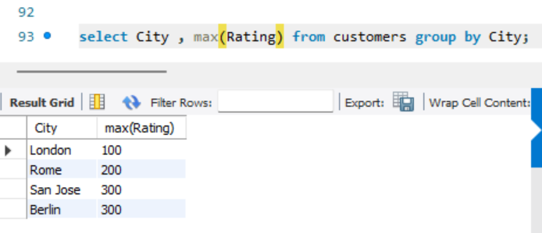
6) Write a query that counts the number of salespeople registering orders for each
day. (If a salesperson has more than one order on a given day, he or she should be
counted only once.).
